##### MICROCONTROLLER BASED COVID RELIEF BOT

##### A PROJECT REPORT

###### ***Submitted by***

##### ANIKET SHUKLA (1901341039)

**GOURISH BHAGAT (1901341040)**

**KIRANJYOTI PUJARI (1901341041)**

**NIVEDITA TRIPATHY (2021341015)**

***in partial fulfillment for the award of the degree***

***of***

##### BACHELOR OF TECHNOLOGY

IN

ELECTRONICS AND COMMUNICATION ENGINEERING

**UNDER THE GUIDANCE OF**

**Mr. NABIN KUMAR NAIK**

**(Sr. Assistant Professor, ECE)**

**SILICON INSTITUTE OF TECHNOLOGY**

**SAMBALPUR, ODISHA, 768200**



BIJU PATNAIK UNIVERSITY OF TECHNOLOGY: ORISSA

BIJU PATNAIK UNIVERSITY OF TECHNOLOGY: ORISSA



**BONAFIDE CERTIFICATE**

Certified that this project report **“MICROCONTROLLER BASED COVID RELIEF BOT”** is the bonafide work of **ANIKET SHUKLA (1901341039), GOURISH BHAGAT (1901341040), KIRANJYOTI PUJARI (1901341041), NIVEDITA TRIPATHY (2021341015)** who carried out the project work under my supervision.

**Mr. Nabin Kumar Naik External Mr. Nabin Kumar Naik**

**(Sr. Assistant Professor, ECE) (Sr. Assistant Professor, ECE)**

**(GUIDE) (HOD)**

**ACKNOWLEDGEMENT**

We would like to express our gratitude to our guide Mr. Nabin Kumar Naik (Sr. Assistant Professor, Dept of ECE) for his guidance and encouragement throughout the project and helping us in the way of developing this project. Without his valuable suggestions and informative discussions, this work would not be possible.

We would also like to thank Mr. Sampad Kumar Pradhan for providing us with all the software tools and his assistance for completing this project.

Finally, our greatest thanks to our parents whose blessings and encouragement made it possible and give this work a concrete shape.

Aniket Shukla (1901341039)

Gourish Bhagat (1901341040)

Kiranjyoti Pujari (1901341041)

Nivedita Tripathy (2021341015)

**DECLARATION**

This project entitled “Microcontroller based Covid Relief Bot” being submitted by me is representation of my own idea and some other ideas referenced from the internet. I have cited the original sources. This project work has not been submitted to any other Universities/Institutions for the award of degree.

Aniket Shukla (1901341039)

Gourish Bhagat (1901341040)

Kiranjyoti Pujari (1901341041)

Nivedita Tripathy (2021341015)

TABLE OF CONTENTS

**TOPIC PAGE NO.**

Bonafide Certificate………………………………………………………………………2

Acknowledgement……………………………………………………………...3

Declaration……………………………………………………………………...4

Abstract…………………………………………………………………………7

List of Figures

1. Arduino Uno Board

2. Different types of Sensors

3. Microcontroller

4. Motor Driver

5. Components of Line Follower

6. Pin Configuration

7. Pin Connections

8. Circuit Design Diagram

9. Flowchart of Covid Relief Bot

10. Forward Direction

11. Left Direction

12. Right Direction

13. Stop Movement

14. Covid Relief Bot

15. Covid Relief Bot Diagram

16. Covid Relief Bot Overview

1. Chapter 1: Introduction
   1. Introduction
   2. Line Follower and its types
   3. Challenges of Line Follower Covid Relief Bot
   4. Project Report Methodology
2. Chapter 2: Literature Review
   1. Introduction
   2. Paper 1
   3. Paper 2
3. Chapter 3: Theory
   1. Arduino Uno
      1. Concept of Arduino Uno
      2. Advantages of Arduino Uno
      3. Problems of Arduino Uno
   2. Sensors

3.2.1. Concept of Sensors

3.2.2. Types of Sensors

3.2.3. Advantages of Sensors

3.3. Microcontroller

3.3.1. Concept of Microcontroller

3.3.2. PID Controller Theory

3.3.3. Advantages of PID Controller

3.4. Motor Driver

3.4.1. Concept of Motor Driver

3.4.2. Types of Motor Drivers

3.4.3. Advantages of Motor Driver

4. Chapter 4: Methodology/Workflow

4.1. Components Used

4.2. Connection of Motor Driver pins

4.3. Requirement of Motor Driver

4.4. Circuit Design Diagram

4.5. Implementation

4.5.1. Workflow Process

4.5.2 Algorithm

4.5.3. Code

5. Chapter 5: Results and Discussions

5.1. Results

5.2. Discussion

6. Conclusion

7. References

**ABSTRACT**

Line Following is one of the most important aspects of robotics. A Line Following Robot is an autonomous robot which is able to follow either a black line that is drawn on the surface consisting of a contrasting color. It is designed to move automatically and follow the line. The robot uses arrays of optical sensors to identify the line, thus assisting the robot to stay on the track. The array of four sensor makes its movement precise and flexible. The robot is driven by DC gear motors to control the movement of the wheels. The Arduino Uno interface is used to perform and implement algorithms to control the speed of the motors, steering the robot to travel along the line smoothly. This project aims to implement the algorithm and control the movement of the robot by proper tuning of the control parameters and thus achieve better performance. In addition, the LCD interface is added in order to display the distance travelled by the robot. It can be used industrial automated equipment carriers, small household applications, tour guides in museums and other similar applications, etc.

**CHAPTER 1: INTRODUCTION**

* 1. **Introduction:**

The line follower robot is a mobile machine that can detect and follow the line drawn on the floor. Generally, the path is predefined and can be either visible like a black line on a white surface with a high contrasted color or it can be invisible like a magnetic field. Definitely, this kind of robot should sense the line with its infrared ray (IR) sensors that installed under the robot. After that, the data is transmitted to the processor by specific transition buses. Hence, the processor is going to decide the proper commends and then it sends them to the driver and thus the path will be followed by the line follower robot.

* 1. **Line Follower and it’s types:**

1. Line follower robot is autonomous that means it automatically follows a line which is
2. pre-defined. Generally, it follows a black line on a white surface or a white line on a black
3. surface. Some of the basic operation of a line follower is given below:
4. ∙ Reading the pre-defined line by IR sensor array which is installed on the front-down side
5. of the robot and sends those readings to the Arduino. The ATMega microcontroller
6. which is built in on Arduino analyzes those readings and do the particular operations.
7. ∙ The steering mechanism is simple in this robot. Three wheels are used, two wheels are
8. on the back part connected with the motors and one independent wheel on the front-
9. middle part of the robot. ∙ On Straight line, the speed is fast and on a turn, speed is
10. relatively slow depending on turn angel. Good motor quality and good sensing quality
11. will increase the robot movement performance.
12. Line follower robot is autonomous that means it automatically follows a line which is
13. pre-defined. Generally, it follows a black line on a white surface or a white line on a black
14. surface. Some of the basic operation of a line follower is given below:
15. ∙ Reading the pre-defined line by IR sensor array which is installed on the front-down side
16. of the robot and sends those readings to the Arduino. The ATMega microcontroller
17. which is built in on Arduino analyzes those readings and do the particular operations.
18. ∙ The steering mechanism is simple in this robot. Three wheels are used, two wheels are
19. on the back part connected with the motors and one independent wheel on the front-
20. middle part of the robot. ∙ On Straight line, the speed is fast and on a turn, speed is
21. relatively slow depending on turn angel. Good motor quality and good sensing quality
22. will increase the robot movement performance.
23. Line follower robot is autonomous that means it automatically follows a line which is
24. pre-defined. Generally, it follows a black line on a white surface or a white line on a black
25. surface. Some of the basic operation of a line follower is given below:
26. ∙ Reading the pre-defined line by IR sensor array which is installed on the front-down side
27. of the robot and sends those readings to the Arduino. The ATMega microcontroller
28. which is built in on Arduino analyzes those readings and do the particular operations.
29. ∙ The steering mechanism is simple in this robot. Three wheels are used, two wheels are
30. on the back part connected with the motors and one independent wheel on the front-
31. middle part of the robot. ∙ On Straight line, the speed is fast and on a turn, speed is
32. relatively slow depending on turn angel. Good motor quality and good sensing quality
33. will increase the robot movement performance.

Line follower robot is autonomous that means it automatically follows a line which is pre-defined. Generally, it follows a black line on a white surface or a white line on a black surface. Some of the basic operation of a line follower is given below: ∙ Reading the pre-defined line by IR sensor array which is installed on the front-down side of the robot and sends those readings to the Arduino. The ATMega microcontroller which is built in on Arduino analyzes those readings and do the particular operations. ∙ The steering mechanism is simple in this robot. Three wheels are used, two wheels are on the back part connected with the motors and one independent wheel on the front-middle part of the robot. ∙ On Straight line, the speed is fast and, on a turn, speed is relatively slow depending on turn angel. Good motor quality and good sensing quality will increase the robot movement performance.

In general, there are two types of line follower. In one type, the line follower follows the black line on the white surface, whereas, in the other type, it follows the white line on the black surface.

* 1. **Challenges of Line Follower Covid Relief Bot:**

Robot can follow the line well when it runs at medium speed but when the speed increases, it can't turn at the sharp corners. In fact, it does turn a little bit before stopping because out of track.

There are several ways to set up speed for robot when it turns such as: one motor runs faster and the other runs slower, one motor runs and the other stops, one motor keep going forward and the other goes reversely.

High speed can be achieved only with smooth transitions between different directions. A bot or motor cannot stop immediately, instead the controller must respect a maximum applicable acceleration/deceleration. So, it's a bad idea to fully stop one wheel during a turn.

* 1. **Project Report Methodology:**

The total report is composed in the following way:

**Chapter 2: Literature Survey -** The literature survey is an effective tool to research about the current developments in the related field and them drawbacks, in order to incorporate a better mechanism in the proposed system.

**Chapter 3: Theory -** This contains information about the underlying technologies and algorithms that have been made use of in the architecture and design of the proposed system.

**Chapter 4: Methodology/Workflow -** This chapter discusses the workflow of this project and to show how it is being executed.

**Chapter 5: Results and Discussion -** This chapter discusses the result obtained from the project and concludes the discussion of the work done so far.

**Chapter 6: Conclusion -** This chapter gives the conclusion of the project which we have worked on.

**Reference:** This chapter lists the various websites and books that have been refereed to, in the making of this project and the project report.

**CHAPTER 2: LITERATURE REVIEW**

* 1. **Introduction:**

Literature survey is the process in which a complete and comprehensive review is conducted encompassing both the published and unpublished work from other alternative sources of information. This review is conducted in the domains of specific interest to the person or researcher. Further, the results of this process are documented. This entire process comes in aid of the researcher to address the important and relevant aspects of the research that had not been addressed prior to the conduction of this research. Therefore, it can be understood that the conduction of literature survey is necessary for the process of gathering secondary data for the research which might prove to be extremely helpful in the research and also designing the architecture of the project. There can be multiple reasons behind the purpose of conducting literature survey.

* 1. **Paper 1:**

**Title:** Robots Under COVID-19 Pandemic: A Comprehensive Survey. YANG SHEN, (Member, IEEE), DEJUN GUO, (Member, IEEE), FEI LONG, LUIS A. MATEOS, (Member, IEEE), HOUZHU DING, (Member, IEEE), ZHEN XIU, RANDALL B. HELLMAN, (Member, IEEE), ADAM KING, SHIXUN CHEN, CHENGKUN ZHANG, (Member, IEEE), AND HUAN TAN, (Senior Member, IEEE) UBTECH North America Research and Development Center, Pasadena, CA 91101, USA Corresponding author: Yang Shen ([yangshen@ieee.org](mailto:yangshen@ieee.org))

**Context:** As a result of the difﬁculties brought by COVID-19 and its associated lockdowns, many individuals and companies have turned to robots in order to overcome the challenges of the pandemic. Compared with traditional human labor, robotic and autonomous systems have advantages such as an intrinsic immunity to the virus and an inability for human-robot-human spread of any disease-causing pathogens, though there are still many technical hurdles for the robotics industry to overcome. This survey comprehensively reviews over 200 reports covering robotic systems which have emerged or have been repurposed during the past several months, to provide insights to both academia and industry. In each chapter, we cover both the advantages and the challenges for each robot, ﬁnding that robotics systems are overall apt solutions for dealing with many of the problems brought on by COVID-19, including: diagnosis, screening, disinfection, surgery, telehealth, care, logistics, manufacturing and broader interpersonal problems unique to the lockdowns of the pandemic. By discussing the potential new robot capabilities and ﬁelds they applied to, we expect the robotics industry to take a leap forward due to this unexpected pandemic.

* 1. **Paper 2:**

**Title:** Combating COVID-19: Study of Robotic Solutions for COVID-19 Sachin Singha), Vijay Kumar Dallab), and Abhishek Shrivastavac) Department of Mechanical Engineering, National Institute of Technology Jamshedpur, Jamshedpur, India- 831014

**Context:** Due to the ongoing coronavirus pandemic caused by the novel virus SARS-CoV-2, the healthcare professionals throughout the world are at the most significant risk of infection from the treatment of infected patients. The risk is not only limited to them, people working in the service sectors who are required to go out and various other commercial institutions are also at economic risks due to the immobilization of resources and workforces. This report deals with the brief overview of the current and potential applications of robotics and automation in healthcare, education, and various industries that prove beneficial not only in the decline of transmission of COVID-19 by maintaining social distancing but also in carrying out tasks more safely and effectively.

**CHAPTER 3: THEORY**

* 1. **Arduino Uno:**

Arduino UNO is a microcontroller board based on the **ATmega328P**. It has 14 digital input/output pins (of which 6 can be used as PWM outputs), 6 analog inputs, a 16 MHz ceramic resonator, a USB connection, a power jack, an ICSP header and a reset button. It contains everything needed to support the microcontroller; simply connect it to a computer with a USB cable or power it with an AC-to-DC adapter or battery to get started.

The ATmega328P can be easily replaced, as it is not soldered to the board. It also features 1kb of EEPROM, a memory which is not erased when powered off.

The Arduino Uno features a barrel plug connector, that works great with a standard 9V battery.

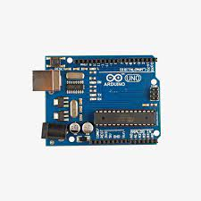

Fig. Arduino Uno Board

* + 1. **Concept of Arduino Uno:**

Arduino Uno is an open-source microcontroller board based on the processor ATmega328P. There are 14 digital I/O pins, 6 analog inputs, a USB connection, a power jack, an ICSP header, and a reset button. It contains all the necessary modules needed to support the microcontroller. Just plug it into a computer with a USB cable or power it with an adapter to get started. You can experiment with your Arduino without worrying too much about it. In the event of a worst-case scenario, you could buy a new one as the Uno is very economical compared to other boards like raspberry pi, STM, etc.

**Microcontroller:**Microcontroller is the central processing unit of Arduino Uno.

**Digital Pins:**There are 14 digital pins on Arduino Uno which can be connected to components like LED, LCD, etc.

**Pins:**There are 6 analog pins on the Uno. These pins are generally used to connect sensors because all the sensors generally have analog values. Most of the input components are connected here.

**Power Supply:**The power supply pins are IOREF, GND, 3.3V, 5V, Vin are used to connecting sensors because all the sensors generally have analog values. Most of the input components are connected here.

**Power Jack:**Uno board can be powered both by external supply and via USB cable.

**USB Port:**This port function is to program the board or to upload the program. The program can be uploaded to the board with the help of Arduino IDE and USB cable.

**Reset Button:**This is used to restart the uploaded program.

* + 1. **Advantages of Arduino Uno:**
* Not much knowledgerequired to get started.
* Fairly low cost, depending on shields you need.
* Lots of sketches and shield available.
* No external programmer or power supply.
  + 1. **Problems of Arduino Uno:**
* No understanding of the AVR microcontroller.
* Sketches and shields can be difficult to modify.
* No debugger included for checking scripts.
* You get no experience of C or professional development tools.
  1. **Sensors:**

A sensor is a device that measures physical input from its environment and converts it into data that can be interpreted by either a human or a machine. Most sensors are electronic (the data is converted into electronic data), but some are simpler, such as a glass thermometer, which presents visual data. People use sensors to measure temperature, gauge distance, detect smoke, regulate pressure and a myriad of other uses.

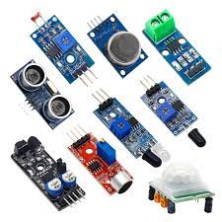

Fig. Different types of Sensors

* + 1. **Concept of Sensors:**

A sensor is a device that detects and responds to some type of input from the physical environment. The input can be light, heat, motion, moisture, pressure or any number of other environmental phenomena. The output is generally a signal that is converted to a human-readable display at the sensor location or transmitted electronically over a network for reading or further processing.

Sensors play a pivotal role in the internet of things. They make it possible to create an ecosystem for collecting and processing data about a specific environment so it can be monitored, managed and controlled more easily and efficiently. IoT sensors are used in homes, out in the field, in automobiles, on airplanes, in industrial settings and in other environments. Sensors bridge the gap between the physical world and logical world, acting as the eyes and ears for a computing infrastructure that analyzes and acts upon the data collected from the sensors. For example, sensors used in weather satellites often require some source of energy to provide meteorological data about the Earth’s atmosphere.

* + 1. **Types of Sensors:**

Several types of Sensors are as follows:

* Vision and Imaging Sensors - Vision and Imaging Sensors/Detectors are electronic devices that detect the presence of objects or colors within their fields of view and convert this information into a visual image for display.
* Temperature Sensors - Temperature Sensors/Detectors/Transducers are electronic devices that detect thermal parameters and provide signals to the inputs of control and display devices. A temperature sensor typically relies on an RTD or thermistor to measure temperature and convert it to an output voltage.
* Radiation Sensors - Radiation Sensors/Detectors are electronic devices that sense the presence of alpha, beta, or gamma particles and provide signals to counters and display devices.
* Proximity Sensors - Proximity Sensors are electronic devices used to detect the presence of nearby objects through non-contacting means. A proximity sensor can detect the presence of objects usually within a range of up to several millimeters, and, doing so, produce a usually dc output signal to a controller.
* Pressure Sensors - Pressure Sensors/Detectors/Transducers are electro-mechanical devices that detect forces per unit area in gases or liquids and provide signals to the inputs of control and display devices. A pressure sensor/transducer typically uses a diaphragm and strain gage bridge to detect and measure the force exerted against a unit area.
* Position Sensors - Position Sensors/Detectors/Transducers are electronic devices used to sense the positions of valves, doors, throttles, etc. and supply signals to the inputs of control or display devices. Key specifications include sensor type, sensor function, measurement range, and features that are specific to the sensor type.
* Photoelectric Sensors - Photoelectric sensors are electrical devices that sense objects passing within their field of detection, although they are also capable of detecting color, cleanliness, and location if needed. These sensors rely on measuring changes in the light they emit using an emitter and a receiver.
* Particle Sensors - Particle Sensors/Detectors are electronic devices used to sense dust and other airborne particulates and supply signals to the inputs of control or display devices. Particle sensors are common in bin and baghouse monitoring. Key specifications include transducer type, minimum detectable particle size, operating temperature range, sample volume, and response time.
* Motion Sensors - Motion Sensors/Detectors/Transducers are electronic devices that can sense the movement or stoppage of parts, people, etc. and supply signals to the inputs of control or display devices. Typical applications of motion detection are detecting the stalling of conveyors or the seizing of bearings. Key specifications include the intended application, sensor type, sensor function, and minimum and maximum speeds.
* Metal Sensors - Metal Detectors are electronic or electro-mechanical devices used to sense the presence of metal in a variety of situations ranging from packages to people. Metal detectors can be permanent or portable and rely on a number of sensor technologies with electromagnetics being popular. Key specifications include the intended application, maximum sensing distance, and certain feature choices like handheld and fixed systems.
* Humidity Sensors - Humidity Sensors/Detectors/Transducers are electronic devices that measure the amount of water in the air and convert these measurements into signals that can be used as inputs to control or display devices. Key specifications include maximum response time and minimum and maximum operating temperatures.
* Contact Sensors - Contact sensors refer to any type of sensing device that functions to detect a condition by relying on physical touch or contact between the sensor and the object being observed or monitored. A simple type of contact sensor is used in alarm systems to monitor doors, windows, and other access points. When the door or window is closed, a magnetic switch provides an indication to the alarm control unit so that the status of that entry point is known. Similarly, when a door or window is opened, the contact sensor alerts the alarm controller of the state of that access point and may trigger an action such as engaging an audible siren.
* Non-Contact Sensors - In contrast to contact sensors, non-contact sensors are devices that do not require a physical touch between the sensor and the object being monitored in order to function. A familiar example of this type of sensor is the motion detector used in security lights. Detection of objects within the range of a motion detector is accomplished using non-mechanical or non-physical means, such as via detection of passive infrared energy, microwave energy, ultrasonic waves, etc. Radar guns used by law enforcement to monitor the speed of vehicles is another example of a form of non-contact sensor.
  + 1. **Advantages of Sensors:**
* Accelerate processes and make them more accurate.
* Collect process and asset data in real time.
* Monitor processes and assets accurately, reliably and continuously.
* Increase productivity and reduce total cost of ownership.
* Lower energy wastage.
  1. **Microcontroller:**

A microcontroller is a compact integrated circuit designed to govern a specific operation in an embedded system. A typical microcontroller includes a processor, memory and input/output (I/O) peripherals on a single chip.

Sometimes referred to as an embedded controller or microcontroller unit (MCU), microcontrollers are found in vehicles, robots, office machines, medical devices, mobile radio transceivers, vending machines and home appliances, among other devices. They are essentially simple miniature personal computers (PCs) designed to control small features of a larger component, without a complex front-end operating system (OS).

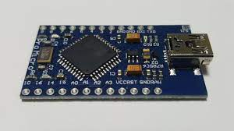

Fig. Microcontroller

* + 1. **Concept of Microcontroller:**

A microcontroller is embedded inside of a system to control a singular function in a device. It does this by interpreting data it receives from its I/O peripherals using its central processor. The temporary information that the microcontroller receives is stored in its data memory, where the processor accesses it and uses instructions stored in its program memory to decipher and apply the incoming data. It then uses its I/O peripherals to communicate and enact the appropriate action.

Microcontrollers are used in a wide array of systems and devices. Devices often utilize multiple microcontrollers that work together within the device to handle their respective tasks.

For example, a car might have many microcontrollers that control various individual systems within, such as the anti-lock braking system, traction control, fuel injection or suspension control. All the microcontrollers communicate with each other to inform the correct actions. Some might communicate with a more complex central computer within the car, and others might only communicate with other microcontrollers. They send and receive data using their I/O peripherals and process that data to perform their designated tasks.

* + 1. **PID Controller Theory:**

A PID controller is an instrument used in industrial control applications to regulate temperature, flow, pressure, speed and other process variables. PID, which stands for proportional integral derivative, controllers use a control loop feedback mechanism to control process variables and are the most accurate and stable controller.

PID control is a well-established way of driving a system towards a target position or level. It's a practically ubiquitous as a means of controlling temperature and finds application in myriad chemical and scientific processes as well as automation. PID control uses closed-loop control feedback to keep the actual output from a process as close to the target or setpoint output as possible. PIDController is a most common control algorithm used in industrial automation and applications and more than 95% of the industrial controllers are of PID type. PID controllers are used for more precise and accurate control of various parameters. Most often these are used for the regulation of temperature, pressure, speed, flow and other process variables. Due to robust performance and functional simplicity, these have been accepted by enormous industrial applications where a more precise control is the foremost requirement.

* + 1. **Advantages of PID Controller:**

The advantage of PID controller is its feasibility and easy to be implemented. The PID gains can be designed based upon the system parameters if they can be achieved or estimated precisely. Moreover, the PID gain can be designed just based on the system tracking error and treats the system to be "Blackbox" if the system parameters are unknown. However, PID controller generally has to balance all three-gains impact to the whole system and may compromise the transient response, such as settling time, overshoots, oscillations. If the system parameters cannot be precisely estimated or achieved, the designed PID gains may not resist the uncertainties and disturbances, and thus present low robustness. Even though the PID gains can be well-designed, the PID controller still has low robust ability compared with the robust controller when the system encounters to multiple challenges from the operating environment of the system, such as temperature, weather, power surge, and so on.

* 1. **Motor Driver:**

Motor drivers acts as an interface between the motors and the control circuits. Motor requires high amount of current whereas the controller circuit works on low current signals. So, the function of motor drivers is to take a low-current control signal and then turn it into a higher-current signal that can drive a motor.

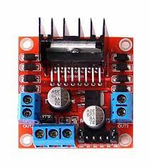

Fig. Motor Driver

* + 1. **Concepts of Motor Driver:**

A motor driver showcases itself as an interface between the motor and the microcontroller. The reason is that the microcontroller and the motor work on different ranges of voltages. The engine will use up a higher current level than the microcontroller.

You require a motor driver module when connecting two devices that operate under different current levels to a power supply voltage. In this case, a motor acts as a third device that steps up or steps down the voltage supply.

The majority of motor drivers in the market now are in the form of ICs. There are different driver motors; hence they have other characteristics. You then connect these motor driver ICs to the motor controller through an H bridge circuit.

* + 1. **Types of Motor Driver:**
* AC Motor Driver - AC Motor Controllers and Drives are electronic devices that modify the input power to motors by typically adjusting the frequency of the power to the motor for the purpose of regulating the output speed and torque. Key specifications include the intended application, drive operating mode, motor type, inverter type, loop system voltage classification, power rating, communication interface, as well as input and output electrical specifications.

AC motor controllers and drives are used primarily in process applications to control the speed of pumps, fans, blowers, etc. They are known as variable speed drives, adjustable frequency drives, or AC inverters. The controller, commonly integrated with the drive circuits, supplies the control signals to the drive.

* DC Motor Driver - DC Motor Controllers and Drives are electrical devices that modify the input power by adjusting the constant or alternating current source to a pulsed, direct current output of varying pulse duration or frequency. Key specifications include the intended application, drive operating mode, motor type, loop system, voltage classification, power rating, output signal type, communication interface, as well as input and output electrical specifications. DC motor controllers and drives are used primarily to control motor speeds and torques for machine tools, electric vehicles, pumps, etc. The controller, commonly integrated with the drive circuits, supplies the control signals to the drive.
* Servomotor -Servo Motor Controllers and Drives are electronic devices that modify the input power by adjusting the constant or alternating current source to a pulsed, current output of varying pulse duration or frequency. Key specifications include the intended application, motor type, drive operating mode, loop system, power rating, output signal type, communication interface, as well as electrical specifications. Servo motor controllers and drives are used primarily in motion control applications in manufacturing and construction environments, among others, and used to control motor speeds, torques, and positions, and may be AC or DC driven. Servo motors are used in many applications including machine tools, micro-positioning, and robotics, among many other types of machinery, such as conveyors or spindle drive systems. The controller, commonly integrated with the drive circuits, supplies the control signals to the drive. Servo drives are also known as servomotor amplifiers.
* Stepper Motor - Stepper Motor Controllers and Drives are electronic devices that modify the input power by adjusting the constant or alternating current source to a pulsed, or "stepped," current output.

Key specifications include the intended application, motor type, drive operating mode, loop system, power rating, output signal type, communication interface, as well as electrical specifications.

Stepper motor controllers and drives are used primarily in motion control applications in manufacturing and construction environments, among others, and used to control motor speeds, torques, and position. They are used in many applications including machine tools, micro-positioning, and robotics, among many other types of machinery, such as conveyors or OEM equipment. The controller, commonly integrated with the drive circuits, supplies the control signals to the drive. Stepper drives are also known as pulse drives and step amplifiers. Stepper controllers are also known as motor indexers.

* + 1. **Advantages of Motor Driver:**
* High level functionality and better performance.
* The circuit is easy to operate. So, we can easily control the robot using inputs.
* It can be used in autonomous and commercial robots, as well.
* The motor deals with heavy current. Due to this current flow, IC gets heated, and we need a heatsink to reduce the heating.
* We use 4 capacitors in this circuit to avoid the fluctuations of voltage while using the motor in one direction and suddenly when we take the opposite direction. This works as a direction shifter without loss.

**CHAPTER 4: METHODOLOGY/WORKFLOW**

* 1. **Components Used:**
* Arduino Uno - 1Nos
* L293D motor driver- 1Nos
* IR sensor module -2 Nos
* 7.4 or 9V battery -1 Nos
* BO motor - 2 Nos
* Motor wheel - 2 Nos
* Castor wheel - 1 Nos
* Hobby robot chassis - 1 Nos
* Wires
* Screw

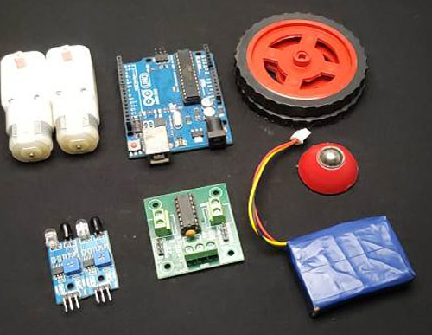

Fig. Components of Line Follower

* 1. **Connections of Motor Driver Pins:**

Pin number 1 and 9 are the enable pins, we connect these two pins to a 5v input to enable the motor.

Pin number 1A, 2A, 3A, and 4A are the control pins.

For e.g. The motor will turn to the right if the pin 1A goes low and 2A goes high, and the motor will turn to the left if 1A goes low and 2A high. So, we connect these pins to the output pins of the decoder.

Pins 1Y, 2Y, 3Y, and 4Y are the motor connection pins.

Note: Vcc2 is the motor driving voltage pin, and only used if you are using a high voltage motor.

Pin connection of Arduino Uno with the Motor driver are as follows:

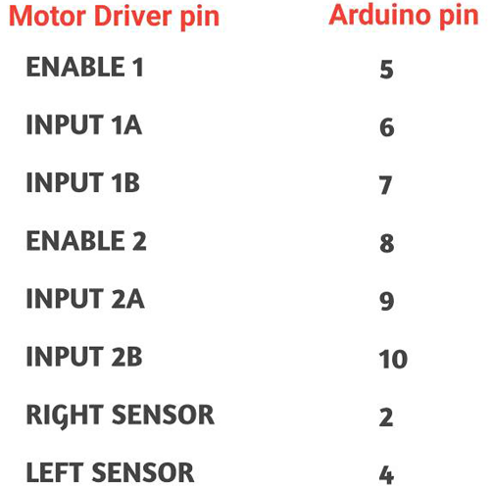

Fig. Pin Configuration

* 1. **Requirement of Motor Driver:**

The reason to use a motor driver here is because the output signal of an Arduino is not sufficient to drive the motor, furthermore, we need to rotate the motors in both directions, therefore we use a motor driver to drive the motor as required and the motor driver is able to supply sufficient current to drive the motor. Here, we are using a **L293D motor driver** which is a **dual h bridge** motor driver and is sufficient for our 2 motors.

The L293D has 16 pins, the pinout of L293D is shown in the below diagram.

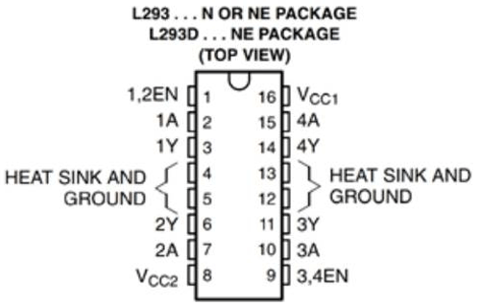

Fig. Pin Connections

* 1. **Circuit Design Diagram:**

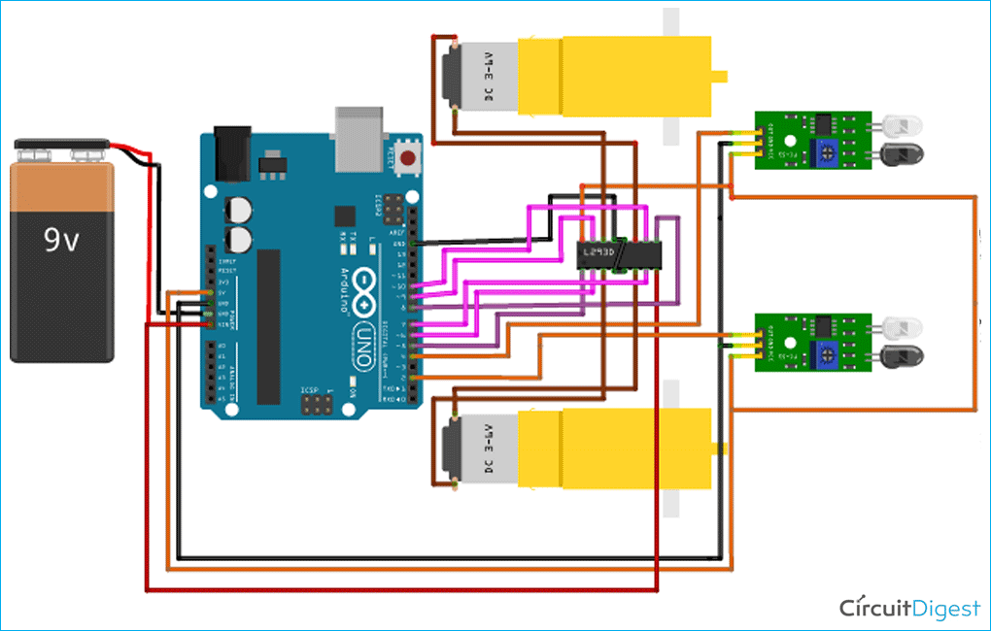

Fig. Circuit Design Diagram

* 1. **Implementations:**

The implementation of the Covid Relief Bot is described in the following flowchart:

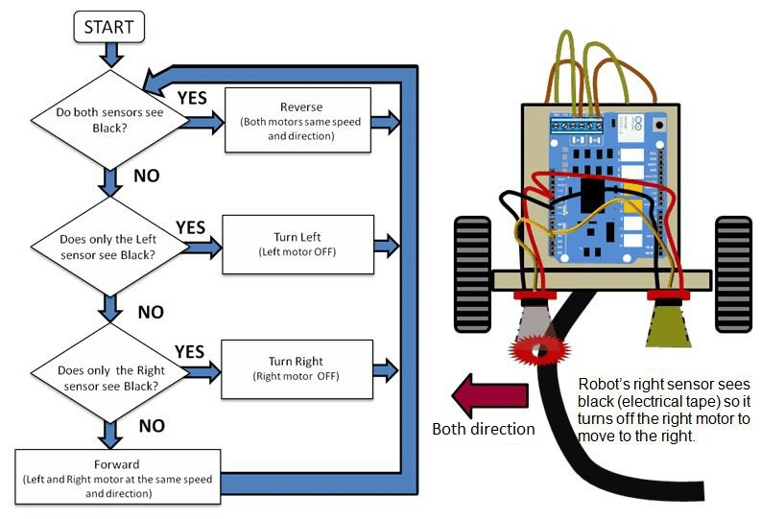

Fig. Flowchart of Covid Relief Bot

* + 1. **Workflow Process:**

A typical line follower robot has two sets of motors, let us call them left motor and right motor. Both motors rotate based on the signal received from the left and the right sensors respectively. The robot needs to perform 4 sets of motion which includes moving forward, turning left, turning right and coming to a halt. The description about the cases is given below.

**Moving** **Forward:**

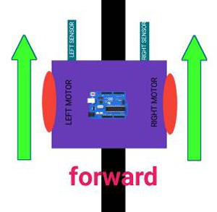

Fig. Forward Direction

In this case, when both the sensors are on a white surface and the line is between the two sensors, the robot should move forward, i.e., both the motors should rotate such that the robot moves in forward direction (both the motors should rotate in the opposite direction due to the placement of motors in our setup. But for the sake of simplicity, we will call the motors rotating forward.)

**Turning LEFT:**

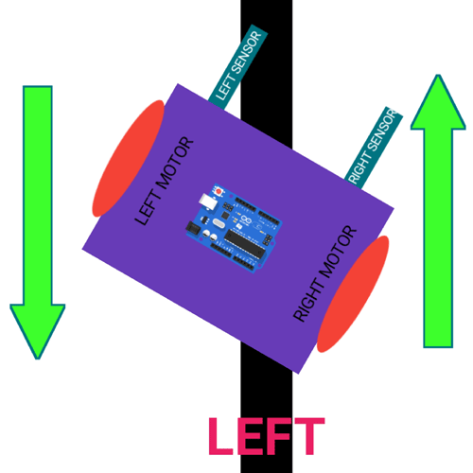

Fig. Left Direction

In this case, the left sensor is on top of the dark line, whereas the right sensor is on the white part, hence the left sensor detects the black line and gives a signal, to the microcontroller. Since, signal comes from the left sensor, the robot should turn to the left direction. Therefore, the left motor rotates backwards and the right motor rotates in forward direction. Thus, the robot turns towards left side.

**Turning RIGHT:**

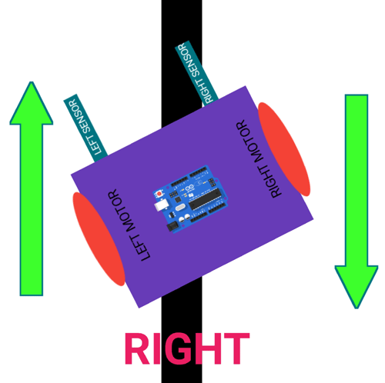

Fig. Right Direction

This case is similar to the left case, but in this situation only the right sensor detects the line which means that the robot should turn in the right direction. To turn the robot towards the right direction, the left motor rotates forward and the right motor rotates backwards and as a result, the robot turns towards the right direction.

**Stopping:**

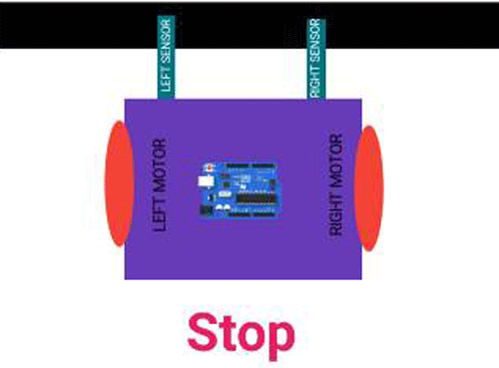

Fig. Stop Movement

In this case, both the sensors are on top of the line and they can detect the black line simultaneously, the microcontroller is fed to consider this situation as a process for halt. Hence, both the motors are stopped, which causes the robot to stop moving.

* + 1. **Algorithm:**
* To make this robot, first we need a robot body; here I am using a homemade chassis. You can either use a readymade chassis or build one yourself.
* Now, place the BO motors to the chassis with the help of some hot glue.
* Next step is to place the motor driver on chassis and connect the motor wires to the output of the motor driver.
* Next, bend the IR LED and sensor.
* Then place the sensors on the downside of the robot, adjust the sensors according to the track width and robot width. Remember that one sensor is for left side detection and another is for the right-side detection.
* Now place the Arduino uno using glue and connect the sensor output pins to digital pin 2 and 4 of the Arduino.
* Connect the VCC pins to 5volt and the ground pins to ground.
* Now, connect the enable pins of the motor driver to pin 5 and 8 of Arduino and connect the motor driver input pins to pin number 6, 7, 9 and 10 of Arduino respectively.
* Finally, connect the battery with the circuit and place the battery on chassis. Here, I have connected everything with jumper wires. To make a permanent setup, you can directly solder everything together.
* Now turn the board upside down and with the help of hot glue gun, attach the castor wheels.
* Finally, add the wheels.
  + 1. **Code:**

// Arduino Line Follower Robot Code

#Define enA 5//Enable1 L293 Pin enA 

#Define in1 6 //Motor1 L293 Pin in1 

#Define in2 7 //Motor1 L293 Pin in1 

#Define in3 9 //Motor2 L293 Pin in1 

#Define in4 10 //Motor2 L293 Pin in1 

#Define enB 8 //Enable2 L293 Pin enB 

#Define R_S 4//ir sensor Right

#Define L_S 2 //ir sensor Left

void setup () { 

pinMode(R_S, INPUT); 

pinMode(L_S, INPUT); 

pinMode(enA, OUTPUT); 

pinMode(in1, OUTPUT); 

pinMode(in2, OUTPUT); 

pinMode(in3, OUTPUT); 

pinMode(in4, OUTPUT); 

pinMode(enB, OUTPUT);

digitalWrite(enA, HIGH); 

digitalWrite(enB, HIGH); 

delay (1000);

}

void loop () {  

if((digitalRead(R_S) == 0) &&(digitalRead(L_S) == 0)) {forward ();} //if Right Sensor and Left Sensor are at White color then it will call forword function

if((digitalRead(R_S) == 1) &&(digitalRead(L_S) == 0)) {turnRight ();} //if Right Sensor is Black and Left Sensor is White then it will call turn Right function  

if((digitalRead(R_S) == 0) &&(digitalRead(L_S) == 1)) {turnLeft ();} //if Right Sensor is White and Left Sensor is Black then it will call turn Left function

if((digitalRead(R_S) == 1) &&(digitalRead(L_S) == 1)) {Stop ();} //if Right Sensor and Left Sensor are at Black color then it will call Stop function

}

void forward () {//forword

digitalWrite(in1, HIGH); //Right Motor forword Pin 

digitalWrite(in2, LOW);  //Right Motor backword Pin 

digitalWrite(in3, LOW);  //Left Motor backword Pin 

digitalWrite(in4, HIGH); //Left Motor forword Pin 

}

void turnRight(){ //turnRight

digitalWrite(in1, LOW);  //Right Motor forword Pin 

digitalWrite(in2, HIGH); //Right Motor backword Pin  

digitalWrite(in3, LOW);  //Left Motor backword Pin 

digitalWrite(in4, HIGH); //Left Motor forword Pin 

}

void turnLeft(){ //turnLeft

digitalWrite(in1, HIGH); //Right Motor forword Pin 

digitalWrite(in2, LOW);  //Right Motor backword Pin 

digitalWrite(in3, HIGH); //Left Motor backword Pin 

digitalWrite(in4, LOW);  //Left Motor forword Pin 

}

void Stop () {//stop

digitalWrite(in1, LOW); //Right Motor forword Pin 

digitalWrite(in2, LOW); //Right Motor backword Pin 

digitalWrite(in3, LOW); //Left Motor backword Pin 

digitalWrite(in4, LOW); //Left Motor forword Pin 

}

**CHAPTER 5: RESULTS AND DISCUSSION**

* 1. **Results:**

The Robot follows a specific line path simultaneously. This line follower robot with multiple modes compatibility works perfectly fine as it is designed to do. And thus, attempt will be made to solve the unplanned and unauthorized parking problems in the resident area using prototype valet parking robot. The slot type and state of the slot will be identified using Sharp IR Sensor. And simultaneously we can perform the operation of Buzzer beep operation, object identification, Lcd display, robot direction control operation and will finally execute parking near to the end.

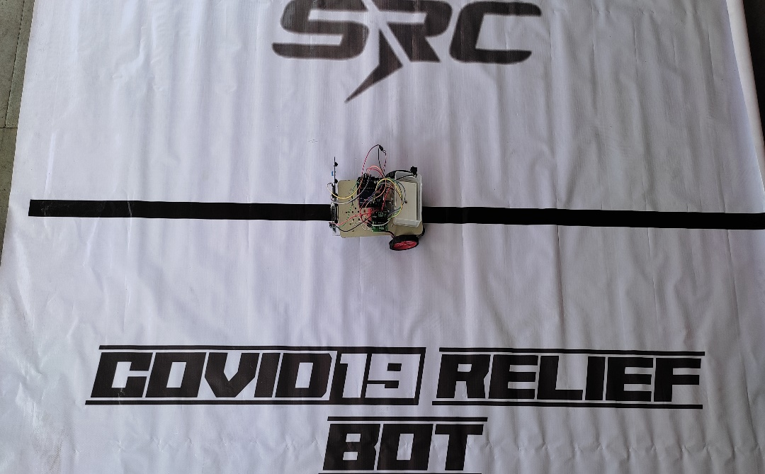

Fig. Covid Relief Bot

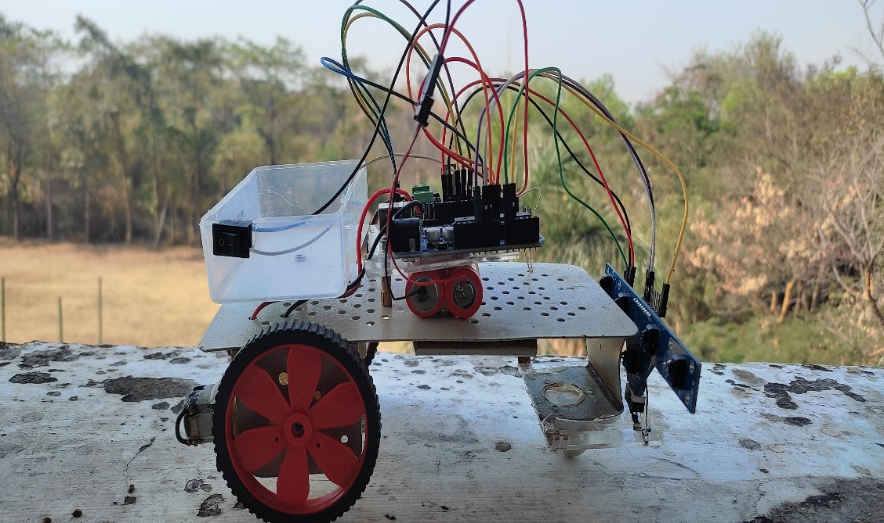

Fig. Covid Relief Bot Diagram

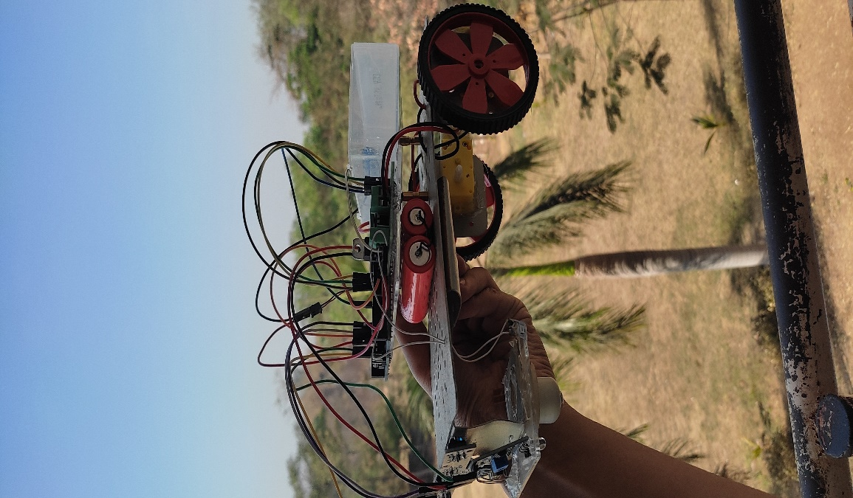

Fig. Covid Relief Bot Overview

* 1. **Discussion:**

**Advantages:**

* These types of robot movement are usually automatic.
* The system in the robot is like Once install and forget.
* It is relatively cheap.
* This type of robot is simple to build.
* They can also be used for long distance.

**Disadvantages:**

* Line follower robot requires 2-3 inches broad line.
* It may not move properly if the black line drawn is of low intensity.
* The IR sensors may sometimes absorb IR rays from surroundings also. As a result, robots may move in improper way.

**Applications:**

* They can be used in industries as automated equipment carriers.
* It can be used for home for floor cleaning etc.
* In hotels they are being used for the transfer of things from one place to another following a straight path.
* Line-following robotic vehicles can carry hazardous materials like radioactive material and poisonous gas cylinders that humans cannot carry easily.
* This robot can be modified and can be fitted along with a wheelchair so that it can be used by disabled people or people who cannot walk due to injuries or accidents.

**CONCLUSION**

In this project, we have designed a line following robot. This robot does not need any remote controller or any controller like Bluetooth, Wi-Fi, GSM, driver etc., it will run automatically with following a line. We have not used any microcontroller. This robot is very low cost but very effective for various purposes. Our project can be used in various sectors like in medicine delivering in hospitals, delivering products in any places, spying, and surveillance and so on. In future we can add several sensors, cameras etc. to get more features.

The Line follower robot works successfully to track on the black line. Above the white surface (art paper) there are some black lines in different directions. The robot still good enough to sense the line and follows the track. Also, the robot is capable to carry some load likely 500gm.

The line following robot project challenged the group to cooperate, communicate and expand understanding of electronics, mechanical systems and their integration with programming. The successful completion of every task demonstrated the potential of mechatronic systems and a positive group dynamic.

**REFERENCES**

1. Pakdaman, Sanaatiyan, M.M.,"Design and Implemen tation of Line Follower Robot,", Second International Conference on Computer and ElectricalEngineering TCCEE '09, vol.2, pp.585-590, Dec.2009.
2. PriyankPatil,"AVR Line Following Robot,” Department of Information Technology K. 1. Somaiya College of Engineering Mumbai, India. Mar 5, 2010.
3. Dean A. Pomerleau; Jay Gowdy; Charles E. Thorpe, “Combining Artificial Neural Networks and Symbolic Processing for Autonomous Robot Guidance,"Engng Applic. Artif. Intell. Vol. 4, No. 4, pp. 279-285, 1991.
4. L1U Shi-Cai,L1U Guang-Jun, "Formation Control of Mobile Robots with Active Obstacle Avoidance," Acta Automatica Sinica, Vol. 33, No. 5,2007.
5. YANG Tian-Tian; L1U Zhi-Yuan; CHEN Hong; PEl Run, "Formation Control and Obstacle Avoidance for Multiple Mobile Robots," ActaAutomatica Sinica, Vol. 34, No. 5, 2008.
6. S. S. Shetty, B. Wollenberg, N. Shabadi, A. S. Kudpaje, V. Rao, and Y. Merchant, ‘‘Vicissitudes in oncological care during COVID19,’’ Oral Oncol., vol. 107, Aug. 2020, Art. no. 104782.
7. Zeng Z, Chen PJ, Lew AA. From high-touch to high-tech: COVID-19 drives robotics adoption. Tourism Geographies. 2020 May 7: 1-1.

M.Zafri Baharuddin, "Analyst of Line Sensor Configuration for

Advanced Line Follower Robot", University Tenaga Nasional.

1. M.Zafri Baharuddin, "Analyst of Line Sensor Configuration for
2. Advanced Line Follower Robot", University Tenaga Nasional.
3. M.Zafri Baharuddin, "Analyst of Line Sensor Configuration for
4. Advanced Line Follower Robot", University Tenaga Nasional.
5. M.Zafri Baharuddin, "Analyst of Line Sensor Configuration for
6. Advanced Line Follower Robot", University Tenaga Nasional.
7. M.Zafri Baharuddin, "Analyst of Line Sensor Configuration for
8. Advanced Line Follower Robot", University Tenaga Nasional.
9. M.Zafri Baharuddin, "Analyst of Line Sensor Configuration for
10. Advanced Line Follower Robot", University Tenaga Nasional.
11. M.Zafri Baharuddin, "Analyst of Line Sensor Configuration for
12. Advanced Line Follower Robot", University Tenaga Nasional.
13. M.Zafri Baharuddin, "Analyst of Line Sensor Configuration for
14. Advanced Line Follower Robot", University Tenaga Nasional.
15. M.Zafri Baharuddin, "Analyst of Line Sensor Configuration for
16. Advanced Line Follower Robot", University Tenaga Nasional.
17. M.Zafri Baharuddin, "Analyst of Line Sensor Configuration for
18. Advanced Line Follower Robot", University Tenaga Nasional.
19. M.Zafri Baharuddin, "Analyst of Line Sensor Configuration for
20. Advanced Line Follower Robot", University Tenaga Nasional.
21. M.Zafri Baharuddin, "Analyst of Line Sensor Configuration for
22. Advanced Line Follower Robot", University Tenaga Nasional.
23. M.Zafri Baharuddin, "Analyst of Line Sensor Configuration for
24. Advanced Line Follower Robot", University Tenaga Nasional.
25. M.Zafri Baharuddin, "Analyst of Line Sensor Configuration for
26. Advanced Line Follower Robot", University Tenaga Nasional.